If we search using the following keywords, the number of publications will be very high (2535 last week and 2538 this week; screenshot below).

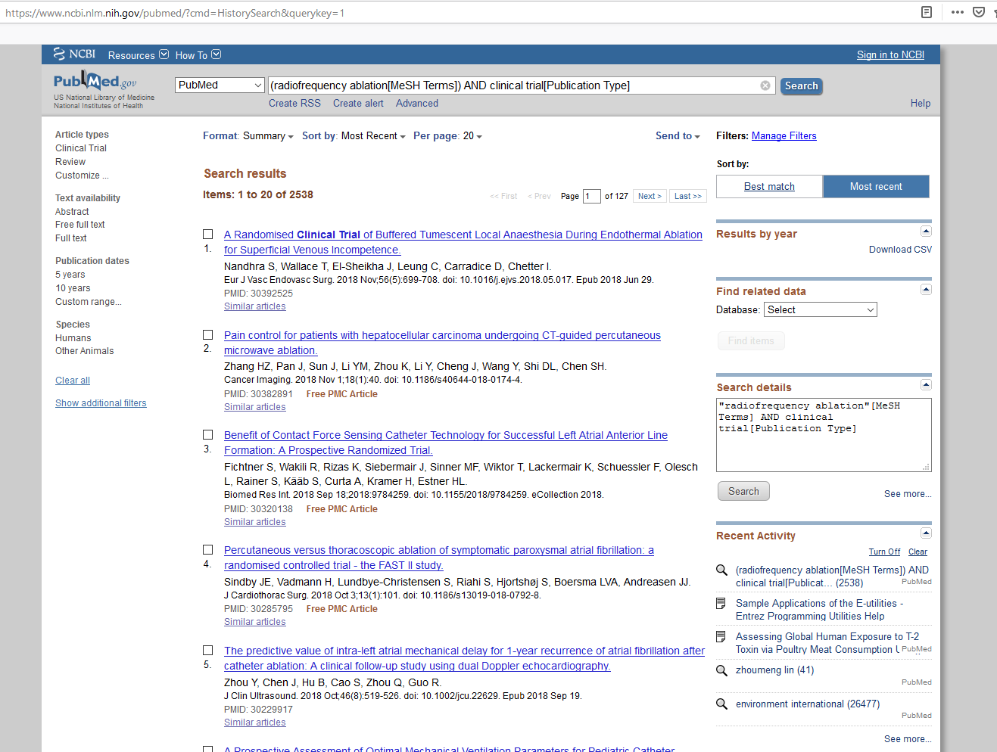

If we specify the specific disease, such as “chronic back pain”, and specify the publication type to be “clinical trial”, the number of relevant publication is only 20 (screenshot below). In the last week’s discussion, we decided that in this project, we would assume the patient has chronic back pain.

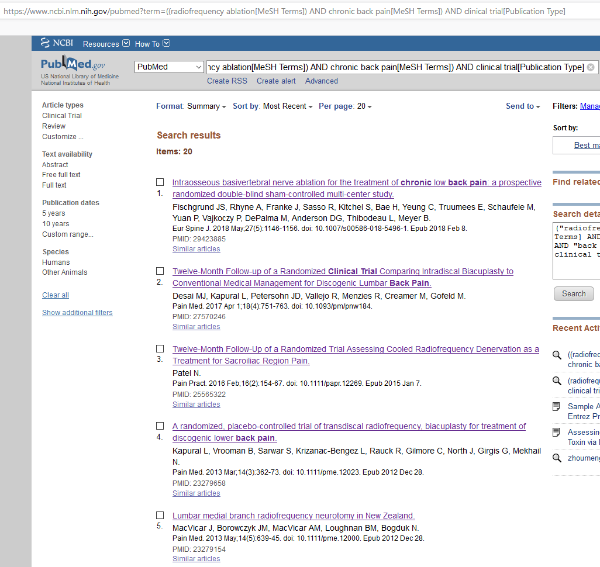

I looked through the abstracts of the latest 10 publications, the majority of these publications supported RFA as a good procedure for chronic back pain, with the effectiveness beyond 1 or 2 years.

I recommend we use the search term

((radiofrequency ablation[MeSH Terms]) AND chronic back pain[MeSH Terms]) AND clinical trial[Publication Type]

The term chronic back pain can be changed to other diseases or other pain, such as chronic sacroiliac joint pain. If we specify a specific pain and the publication type as clinical trial, we won’t get too many publications.